A

MINI PROJECT REPORT

ON

**Voice Controlled IoT Based Hand Operated Cutting Machine For Agricultural Purpose**

Submitted To

**SAVITRIBAI PHULE PUNE UNIVERSITY, PUNE**

**SUBMITTED BY**

**NAME: SEAT NO:.**

Daspute Abhishek Kailas T190115013

Bhonde Hemant Balasaheb T190115009

**Guided By**

**Prof.S.P Bangal**



**DEPARTMENT OF**

**ELECTRONICS AND COMPUTER ENGINEERING**

**Loknete Dr. Balasaheb Vikhe Patil (Padmabhushan Awardee)**

**Pravara Rural Engineering College, Loni – 413736**

**Tal. Rahata Dist. Ahmednagar, (M.S.), India**

**2023–24**

**Loknete Dr. Balasaheb Vikhe Patil (Padmabhushan Awardee)**

**Pravara Rural Engineering College, Loni – 413736**

**DEPARTMENT OF ELECTRONICS AND COMPUTER ENGINEERING**



**Certificate**

**This is to certify that project report entitled**

**Voice Controlled IoT Based Hand Operated Cutting Machine For Agricultural Purpose**

**SUBMITTED BY**

**NAME: SEAT NO:.**

Daspute Abhishek Kailas T190115013

Bhonde Hemant Balasaheb T190115009

**The students of TE Electronics and Computer Engineering during the academic year 2023–24.**

**This project report embodies the work carried out by the candidate, toward the partial fulfilment of third year degree course in Electronics and Computer Engineering conferred by the Savitribai Phule Pune University.**

**Prof.S.P Bangal Dr. S. A. Shaikh Mrs. S. S. Lavhate PROJECT GUIDE PROJECT CO-ORDINATOR HOD, ECE**

**QUALITY POLICY**

**Institute Vision**

Enrich the youth with skills and values to enable them to contribute in the development of society: nationally and globally.

**Institute Mission**

To provide quality technical education through effective teaching-learning and research to foster youth with skills and values to make them capable of delivering significant contribution in local to global development.

**Department Vision**

Promote effective teaching learning in the fields of electronics and computer engineering to produce nationally, globally competitive engineers that are needed to meet the evolving demands of industry and society.

**Department Mission**

Imparting latest multidisciplinary technical knowledge in the field of Electronics and Computer Engineering and providing an opportunity for creating talent in students to take up challenges for the benefits of society and industry.

**Program Outcomes**

**PO1 Engineering knowledge:** Apply the knowledge of mathematics, science, engineering fundamentals, and an engineering specialization to the solution of complex engineering problems.

**PO2 Problem analysis:** Identify, formulate, review research literature, and analyze complex engineering problems reaching substantiated conclusions using first principles of mathematics, natural sciences, and engineering sciences.

**PO3 Design/development of solutions:** Design solutions for complex engineering problems and design system components or processes that meet the specified needs with appropriate consideration for the public health and safety, and the cultural, societal, and environmental considerations.

**PO4 Conduct investigations of complex problems:** Use research-based knowledge and research methods including design of experiments, analysis and interpretation of data, and synthesis of the information to provide valid conclusions.

**PO5 Modern tool usage:** Create, select, and apply appropriate techniques, resources, and modern engineering and IT tools including prediction and modelling to complex engineering activities with an understanding of the limitations.

**PO6 The engineer and society:** Apply reasoning informed by the contextual knowledge to assess societal, health, safety, legal and cultural issues and the consequent responsibilities relevant to the professional engineering practice.

**PO7 Environment and sustainability:** Understand the impact of the professional engineering solutions in societal and environmental contexts, and demonstrate the knowledge of, and need for sustainable development.

**PO8 Ethics:** Apply ethical principles and commit to professional ethics and responsibilities and norms of the engineering practice.

**PO9 Individual and team work:** Function effectively as an individual, and as a member or leader in diverse teams, and in multidisciplinary settings.

**PO10 Communication:** Communicate effectively on complex engineering activities with the engineering community and with society at large, such as, being able to comprehend and write effective reports and design documentation, make effective presentations, and give and receive clear instructions.

**PO11 Project management and finance:** Demonstrate knowledge and understanding of the engineering and management principles and apply these to one’s own work, as a member and leader in a team, to manage projects and in multidisciplinary environments.

**PO12 Life-long learning:** Recognize the need for, and have the preparation and ability to engage in independent and life-long learning in the broadest context of technological change.

**ACKNOWLEDGEMENT**

Inspiration and guidance are invaluable in all aspects of life, especially when it is academic. We fail to find the adequate words to express the deep sense of gratitude to our respected Head of Department of Electronics and Computer Engineering MRS. S. S. LAVHATE and Project Coordinator DR. S. A. SHAIKH and Guide **Prof.S.P Bangal** who put their careful guidance and interest through which we have completed our project work.

The indebt necessity for encouragement, help and sympathetic attitude which we received from them during preparation of our work cannot be expressed in words.

Last but not the least we would like to remember our family members with whose continuous inspiration, this work wouldn't have been successfully completed. Every work is the outcome of full proof planning, continuous hard work and organized team effort. This work is the combination of the all above together, sincerely.

**Student Name**

1. **BHONDE HEMANT BALASHEB**
2. **DASPUTE ABHISHEK KAILAS**

**DECLARATION**

We here with submit the Project Report titled **" Voice Controlled IoT Based Hand Operated Cutting Machine For Agricultural Purpose"**, to Pravara Rural Engineering College, Loni for impartial fulfilment of mini project. We carried it under the guidance of **Prof.S.P Bangal**, Department of Electronics and Computer Engineering, Loni. This project report has not been submitted to any other University/Institute for award of any degree or diploma.

1. BHONDE HEMANT BALASAHEB
2. DASPUTE ABHISHEK KAILAS

Date: / / 2024

Place: Loni

**ABSTRACT**

The main purpose of this project is to design a grass cutting machine system which makes the grass cutting will very easy and more convenient. The IOT based solar powered grass cutting machine is one of the robotic vehicle. It is operated on battery and battery is energies by solar panel. This system requires 12 volt battery for giving power to robotic vehicle movement as well as grass cutter motor. The working principle of grass cutter and machine motor is completely controlled by microcontroller. It controls working of all motors. We can handle movement of vehicle motor with the help of microcontroller. In this project we are using Bluetooth technology for controlling the robotic vehicle. The Bluetooth handled by Android smartphone application. IOT is one of the important technology. This technology is used in our project for checking the battery condition.

|  |  |  |
| --- | --- | --- |
| **INDEX** | | |
| **Sr. No** | **CONTENTS** | **Page No** |
|  | **Cover Page** |  |
| **CERTIFICATE** | 2 |
| **ACKNOWLEDGEMENT** | 7 |
| **DECLARATION** | 8 |
| **ABSTRACT** | 9 |
|  | **Table of Contents** | 10 |
| **1** | **INTRODUCTION** | 12 |
| 1.1 Project Overview | 12 |
| 1.2 Motivation and Significance | 13 |
| 1.3. Aim and Objectives | 13 |
| 1.4 Problem Statement | 14 |
| **2** | **LITERATURE REVIEW** | 15 |
| 2.1 Related Work | 15 |
| **3** | **SYSTEM DESIGN** | 16 |
| 3.1.Block Diagram | 16 |
| 3.2 Circuit Schematics | 17 |
| 3.3 Component Selection | 19 |
| **4** | **IMPLIMENTATION** | 27 |
|  | 4.2 Testing and Verification | 27 |
| **5** | **RESULTS AND EVALUATION** | 29 |
| 5.1. Hardware Demonstration | 29 |
| 5.2 Performance Evaluation | 30 |
| **6** | **CONCLUSION AND FUTURE WORK** | 32 |
| 6.1. Conclusion | 32 |
| 6.2 Future Work | 32 |
| **7** | **REFERENCES** | 33 |
|  | **Appendix** | 34 |
|  | source code | 34 |

**LIST OF FIGURES**

|  |  |  |  |
| --- | --- | --- | --- |
| **Sr.No** | **Fig.No** | **Name of Fig.** | **Page No.** |
| 1 | 1.1 | Voice Control Gress Cutter | 12 |
| 2 | 1.2 | Voice Controller Grass Cutter Machine | 16 |
| 3 | 3.1 | Circuit Diagram | 17 |
| 4 | 3.2 | Arduino uno | 20 |
| 5 | 3.3 | Motor Driver | 22 |
| 6 | 3.4 | Bluetooth Module | 23 |
| 7 | 3.5 | DC Motor | 24 |
| 8 | 3.6 | Cleaning Grass Motor | 25 |
| 9 | 3.7 | Solar Panel & Converter | 26 |
| 10 | 3.8 | 12 volt battery | 26 |

**CHAPTER 1**

**INTRODUCTION**

* 1. **Project Overview:**
* Voice Controlled IoT Based Hand Operated Cutting Machine For Cleaning Grass
* The grass cleaner will collect the grass after the cutter cuts the grass
* The system used 12V batteries to power the vehicle movement motors as well as the grass cutter motor and grass cleaner motor
* We also use a solar panel to charge the battery so that there is no need for charging it externally. .
* The grass cutter and vehicle motors are interfaced to an Arduino family microcontroller that controls the working of all the motors.
* Here we have interfaced an ultrasonic sensor for object detectionOn obstacle detection the ultrasonic sensor monitors it and the microcontroller thus Stops
* the grass cuter motor to avoid any damage to the object/human/animal whatever it is.The microcontroller then turns the robotic as long as it gets clear of the object and then moves the grass cutter in forwarding direction
* 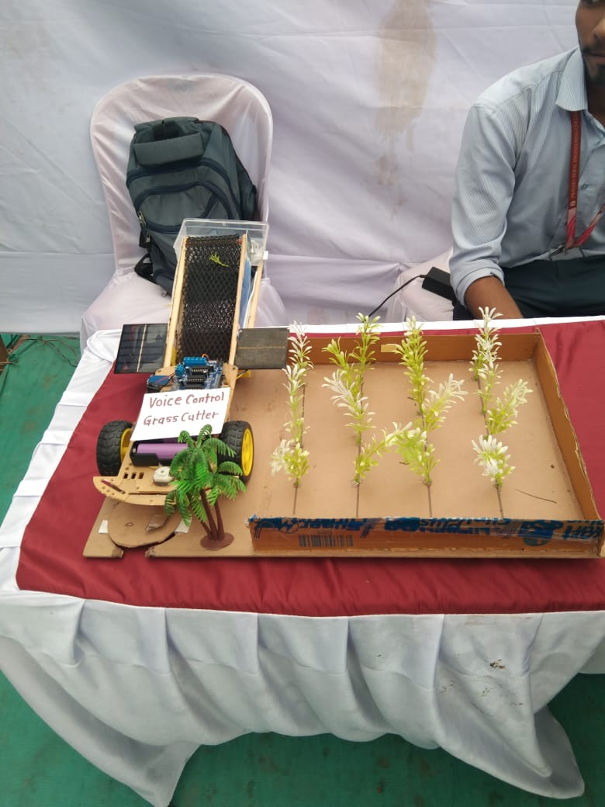

**Fig 1.1 Voice Control Gress Cutter**

**1.2 Motivation and Significance:**

**Motivation:**

* The lawn mower industry has not seen any disruption in product development in the recent past.
* mower designs and also previous human effort and time is being lost doing a job
* The onerous to manage nature of the engine was improved upon by

**Significance:**

* **Environmentally Friendly**: By harnessing solar power as the primary energy source, the system reduces reliance on fossil fuels
* **Energy Efficiency**: Solar power is a renewable energy source
* **Labor Savings**: The fully automated nature of the system eliminates the need for manual labor in grass cutting tasks. This saves time, effort, and labor costs, particularly in large outdoor areas such as parks, golf courses, and agricultural fields..

**1.3Aim and Objectives:**

**AIM**

Integrate voice recognization technology with grass cutter for hands free operation and enhance user experience.

**Objectives**

1. **Autonomous Operation**: Develop a system capable of autonomously navigating through the grassy terrain, identifying areas that require cutting, and executing cutting tasks without human intervention.
2. **Solar Power Integration**: Utilize solar energy as the primary power source for operating the grass cutter, thereby reducing reliance on traditional energy sources and promoting environmental sustainability.
3. **Remote Control and Monitoring**: Incorporate remote control capabilities via wireless communication protocols such as Bluetooth Wi-Fi, allowing users to monitor and control the grass cutter from a distance using a mobile device or a computer.

**1.4 .Problem Statement:**

The time where there is a merger of innovation and ecological mindfulness, every one of the customers are likewise investigating ways for utilizing most extreme efficient power vitality and contribute in decrease of their own carbon impressions. Contamination The solar based Grass cutter enables buyer in lessening the green house impact by decrease in the carbon discharge.

**CHAPTER 2**

**LITERATURE REVIEW**

**Review :**

Sivarao, T.J.S.Anand, Hambali, Minhat, Faizul et al [1] presented a review of researches done on the subject of automated tractor. An autonomous tractor is a vehicle that can operate without or with minimal human control, Pratik Patil, Ashwini Bhosale, Prof. Sheetal Jagtap et al[2] described about an automatic lawn cutter that will help the user to cut the grass in their lawn with less efforts. The different sensors are used it will detect and avoid objects and humans while mowing.

B.P. Dilip, N.B. Pagar, V.S. Ugale, S. Wani, M. Sharmila et al[3] Design and implementation of automatic solar grass cutter. S.S. Patil, Solar based grass cutting. Int. J. Electr. Electron. Eng. (IJEEE) (2017)3. S. Jain, A. Khalore et al[4]Selfpropelled and guided automatically along a desired path. The benefits from such a system are useful for agriculture industry by reducing labour cost and time, as well as improving output efficiency by eliminating human errors.

S. Patil, Self-efﬁcient and sustainable solar powered robotic lawn mower.Int. J. Trend Res. Dev. (IJTRD) 2(6) (2015) et al[5].The main objective of this automatic lawn cutter is that the user can specify the area that is to be mown and also the height of grass as per there requirement by using the keypad. This design contains a microcontroller like ATmega 16, multiple sensors, LCD Display, Keypad.Ernest L. Hall et al[6]The system operates on the same principle as the Lawn Ranger except it uses a cable beneath the surface of a persons lawn. The mower uses this wire along with its sensors to allow the robot to maneuver around . M. Alam, V.V. Singh, V.Y. Chandan, IOT based grass cutter with solar panel. IJSER (2019).https://www.ijser.org8. G.D. Dattatraya et al [7]While keeping the system on track. The mower will continue to operate as long as the mower has energy, from the sun. The robot is equipped with a flexible bu mper that when activated backs the mower up and continues the robot on a different path. It has the advantage of cutting grass in the form of a mulch so that the use of a grass catcher or raking is not required. Sharmila, Design and implementation of automatic solar grass cutter.

**CHAPTER 3**

**System Design**

**3.1Block Diagram**

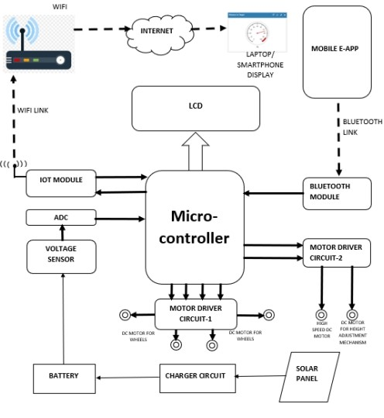

Cleaning Grass Motor

**Fig3.1. Voice Controller Grass Cutter Machine**

**Working:**

For implementing of hardware parts we have used Arduino UNO ,L293D the DC motor driver. The work is mainly divided in three modules in which first are: creation of application and user interaction with application . it will Graphical interface for any non-technical user can also interact with application .it will also provides option like select different modes of controlling wheel chair like(voice commands)for controlling .In this microcontroller maintains unique information of commands and match that commands with user inputs and perform action like moving left, Right, Forward ,Backward ,Stop .The second module is connection of application to microcontroller . In this module Android application is started first and then it is connected to the microcontroller via Bluetooth. After starting the Bluetooth we will get the list of device near available and need to pair with the microcontroller and then after connecting it become ready to perform action with Device Driver and wheel chair . After forming connection with application **Wor**

,microcontroller initializes the connection with device driver (i.e. left and right side motor ) and after taking the input from user it will send that input in the form of bits to Device driver .

**3.2 Circuit Schematics:**

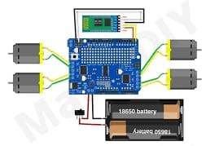

**Fig3.2 Circuit Diagram**

**Voice Input**: The circuit is equipped with a voice recognition module or a voice recognition chip that can understand specific voice commands. Common voice recognition modules include the EasyVR Shield, the HM2007 Speech Recognition Module, or software-based solutions like the Raspberry Pi with a microphone.

**Microcontroller**: The voice commands detected by the voice recognition module are sent to a microcontroller, typically an Arduino or a Raspberry Pi. The microcontroller processes the voice commands and triggers specific actions based on the recognized commands.

**Motor Control**: The microcontroller controls the operation of the grass cutter's motor(s) based on the voice commands received. It may send signals to motor drivers or relays to start, stop, or change the direction of the motor(s) powering the grass cutter blades.

**Safety Features**: The circuit may include safety features to ensure safe operation, such as emergency stop buttons or sensors to detect obstacles and stop the grass cutter if necessary. These safety features help prevent accidents and ensure user safety during operation.

**Power Supply**: The circuit requires a stable power supply to operate the microcontroller, voice recognition module, and other electronic components. Depending on the design, the circuit may be powered by batteries, a power adapter, or a combination of both.

**Feedback Mechanism**: To provide feedback to the user, the circuit may include indicators such as LEDs or an LCD display to indicate the status of the grass cutter (e.g., running, stopped) or to display error messages in case of any issues.

**Integration with Grass Cutter**: The circuit is integrated with the grass cutter's existing control system or directly with the motor(s) to control its operation effectively. This integration ensures seamless communication between the voice control circuit and the grass cutter mechanism.

**Testing and Calibration**: Before deployment, the circuit needs to be tested thoroughly to ensure that it recognizes voice commands accurately and controls the grass cutter's operation reliably. Calibration may be required to adjust sensitivity and improve recognition performance.

voice-controlled grass cutter circuit provides a convenient and hands-free way to operate a grass cutter, offering users greater flexibility and ease of use, especially in scenarios where manual control may be impractical or inconvenient.

### List Of Components:

|  |  |
| --- | --- |
| **Sr.No** | **Components** |
| **1** | **Arduino Uno** |
| **2** | **L293D Motor Driver** |
| **3** | **HC-05 Bluetooth Module** |
| **4** | **DC Motors** |
| **5** | **Battery** |
| **6** | **Solar Panel & Converter** |
| **7** | **Cutter** |
| **8** | **Cleaning Grass Motor** |
| **9** | **Wires** |

**1.Arduino Uno:**

Arduino is an open-source computer hardware and software company, project, and user community that designs and manufactures single-board microcontrollers and microcontroller kits for building digital devices and interactive objects that can sense and control objects in the physical and digital world. The project's products are distributed as open-source hardware and software, which are licensed under the GNU Lesser General Public License (LGPL) or the GNU General Public License (GPL), permitting the manufacture of Arduino boards and software distribution by anyone. Arduino boards are available commercially in preassembled form, or as do-it-yourself (DIY) kits. Arduino board designs use a variety of microprocessors and controllers. Subhajit Dey [13]. The boards are equipped with sets of digital and analog input/output (I/O) pins that may be interfaced to various expansion boards or Breadboards (shields) and other circuits. The boards feature serial communications interfaces, including Universal Serial Bus (USB) on some models, which are also used for loading programs from personal computers. The microcontrollers are typically programmed using a dialect of features from the programming languages C and C++. In addition to using traditional compiler toolchains

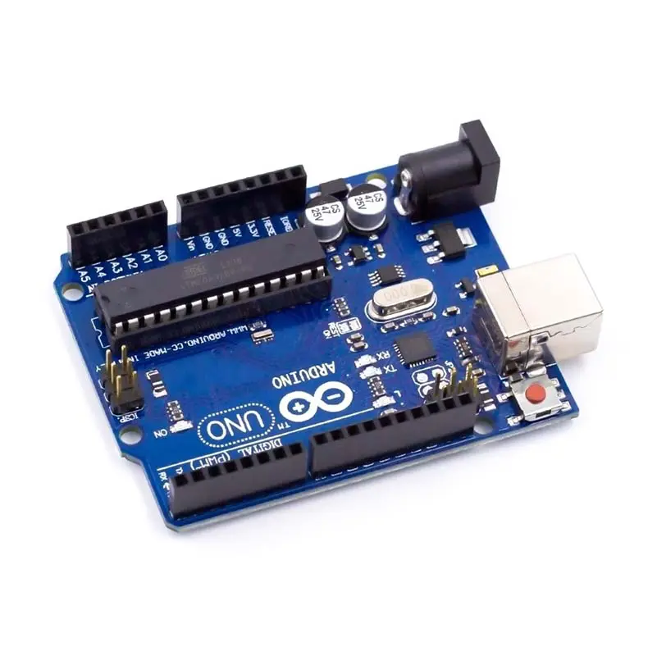**Fig3.3 ARDUINO UNO**

**Features of the Arduino**

UNO Microcontroller: ATmega328

Operating Voltage: 5V

Input Voltage (recommended): 7-12V

Input Voltage (limits): 6-20V

Digital I/O Pins: 14 (of which 6 provide PWM output)

Analog Input Pins: 6

DC Current per I/O Pin: 40 m A

DC Current for 3.3V Pin: 50 mA

**Arduino Hardware Part:**

Arduino is open-source hardware. The hardware reference designs are distributed under a Creative Commons Attribution Share-Alike 2.5 license and are available on the Arduino website. Layout and production files for some versions of the hardware are also available. Although the hardware and software designs are freely available under copy left licenses, the developers have requested the name Arduino to be exclusive to the official product and not be used for derived works without permission. Mok Vee Hoong [14]. The official policy document on use of the Arduino name emphasizes that the project is open to incorporating work by others into the official product. Several Arduino-compatible products commercially released have avoided the project name by using various names ending in -Arduino . Most Arduino boards consist of an Atmel 8-bit AVR microcontroller (ATmega8, ATmega168, ATmega328, ATmega1280, ATmega2560) with varying amounts of flash memory, pins, and features. The 32-bit Arduino Due, based on the Atmel SAM3X8E was introduced in 2012.Avadhoot R.et al[15]. The boards use single or double-row pins or female headers that facilitate connections for programming and incorporation into other circuits.

**Arduino Software Part**

IDE The Arduino integrated development environment (IDE) is a cross-platform application (for Windows, macOS, Linux) that is written in the programming language Java. It originated from the IDE for the languages Processing and Wiring. Avadhoot R.et al [15].It includes a code editor with features such as text cutting and pasting, searching and replacing text, automatic indenting, brace matching, and syntax highlighting, and provides simple one-click mechanisms to compile and upload programs to an Arduino board. It also contains a message area, a text console, a toolbar with buttons for common functions and a hierarchy of operation menus. Jinan N. Shehab et al [16]. The source code for the IDE is released under the GNU General Public License, version The Arduino IDE supports the languages C and C++ using special rules of code structuring. The Arduino IDE supplies a software library from the Wiring project, which provides many common input and output procedures .R. K. Kodaly et al [12]. User-written code only requires two basic functions, for starting the sketch and the main program loop, that are compiled and linked with a program stub main () into an executable cyclic executive program with the GNU toolchain, also included with the IDE distribution. The Arduino IDE employs the program avrdude to convert the executable code into a text file in hexadecimal encoding that is loaded into the Arduino board by a loader program in the board's firmware. Subhajit Dey [13].

**2.Motor Driver:**

A motor driver IC is an integrated circuit chip which is usually used to control motors in autonomous robots. Motor driver IC's act as an interface between microprocessors in robots and the motors in the robot. The most commonly used motor driver IC’s are from the L293 series such as L293D, L293NE, etc. These IC's are designed to control 2 DC motors simultaneously. L293D consist of two H-bridge. H-bridge is the simplest circuit for controlling a low current rated motor. For this tutorial we will be referring the motor driver IC as L293D only. L293D has 16 pins, they are comprised as follows:

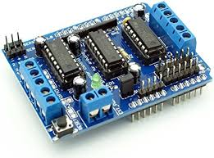

**Fig3.4. Motor Driver**

**3.HC-05 Bluetooth Module:**

HC‐05 module is an easy-to-use Bluetooth SPP (Serial Port Protocol) module, designed for transparent wireless serial connection setup. The HC-05 Bluetooth Module can be used in a Master or Slave configuration, making it a great solution for wireless communication. This serial port Bluetooth module is fully qualified Bluetooth V2.0+EDR (Enhanced Data Rate)3Mbps Modulation with complete 2.4GHz radio transceiver and baseband. Sushant Kumar and S.S. Solanki [19].It uses CSR Blue core 04‐ External single chip Bluetooth system with CMOS Technology and with AFH (Adaptive Frequency Hopping Feature). Bluetooth Module HC-05 the Bluetooth module HC-05 is a MASTER/SLAVE module. By default, the factory setting is SLAVE. The Role of the module (Master or Slave) can be configured only by AT COMMANDS. The slave modules cannot initiate a connection to another Bluetooth device, but can accept connections. Master module can initiate a connection to other devices. The user can use it simply for a serial port replacement to establish connection between MCU and GPS, PC to your embedded project, etc. Subhajit Dey [13].

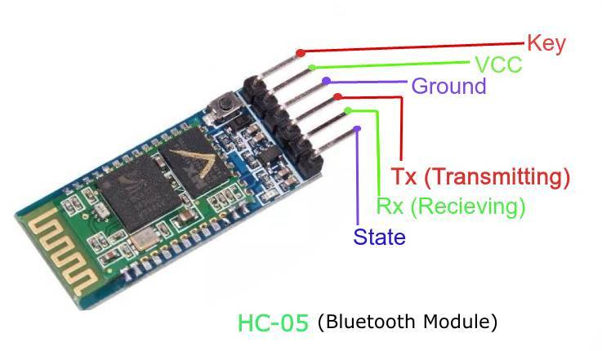

**Fig3.5 Bluetooth Module**

**3.1 bluetooth Module (HC-05 Bluetooth Module) HC-05 Specification:**

1. Bluetooth protocol: Bluetooth Specification v2.0+EDR
2. Frequency: 2.4GHz ISM band
3. Modulation: GFSK (Gaussian Frequency Shift Keying)
4. Emission power: ≤4dBm, Class 2
5. Sensitivity: ≤-84dBm at 0.1% BER
6. Speed: Asynchronous: 2.1Mbps (Max) / 160 kbps,
7. Synchronous: 1Mbps/1Mbps
8. Security: Authentication and encryption
9. Profiles: Bluetooth serial port
10. Power supply: +3.3VDC 50mA
11. Working temperature: -20 ~ +75Centigrade
12. Dimension: 26.9mm x 13mm x 2.2 mm

**4.Arduino IDE:**

The Arduino Software (IDE) includes a text editor for writing code, a message box, a text console, a toolbar with buttons for basic functions, and a series of menus. It communicates with the Arduino hardware and uploads applications to it.

**5.DC Motor**

A DC Motor is an electrical device that converts electrical energy into mechanical energy. Going by the DC motor full form, the device uses Direct Current (DC) for its operation. A rotary component called an armature coil rests inside the motor’s casing, surrounded by strong [permanent magnets](https://testbook.com/physics/permanent-magnet). When a current is applied to the armature through a rotary electric switch called a [commutator](https://testbook.com/physics/commutator), the magnetic field created by the armature interacts with the magnetic field of the stationary magnet to apply a torque on the armature, causing it to rotate.

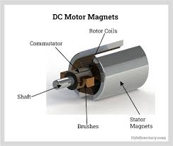

**Fig3.5 DC Motor**

The basic working principle of a DC motor is that whenever a current-carrying conductor is placed in a magnetic field, it experiences a force. This force is known as the [Lorentz force](https://testbook.com/physics/lorentz-force), and it is responsible for the rotation of the motor's armature.  
The armature is a rotating part of the motor that is made up of coils of wire. When current flows through these coils, they create a magnetic field that interacts with the magnetic field of the permanent magnets or [electromagnets](https://testbook.com/physics/what-are-electromagnets) that are also part of the motor. This interaction creates a force that causes the armature to rotate.  
The rotation of the armature is transferred to the output shaft of the motor, which can then be used to do work, such as driving a pump, fan, or other machine.

**6.Cleaning Grass Motor**

Start by disconnecting the spark plug lead and securing it away from the spark plug.

Remove shroud or engine screen, if equipped, and snap off the plastic blower housing. ...

Clean the cooling fins, the inside of the blower housing and the flywheel fins, using a small bristle brush

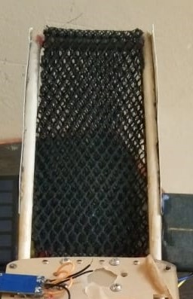

**Fig3.6 Cleaning Grass Motor**

**7.Solar Panel & Converter**

In any solar system, [inverter](https://www.elprocus.com/what-is-an-inverter-types-circuit-diagram-applications/) plays an essential role like a brain. The main function of this is to alter DC power to AC power which is generated from the solar array. It allows for monitoring the system so this system operators can observe how this system is working. If you are considering a solar panel system for your home, one of the key decisions you make is the type of inverter to install. Inverters convert direct current (DC) energy which is generated from the solar panels into usable [alternating current (AC) energy](https://www.elprocus.com/alternating-current-and-direct-current-and-its-applications/). After the panels themselves, inverters are the most important equipment in the solar power system. The inverter gives analytical information to assist in identifying operations & maintenance to fix issues of the system. This article discusses an overview of a solar system.

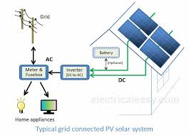

**Fig3.7 Solar Panel & Converter**

**8. 12 v Battery:**

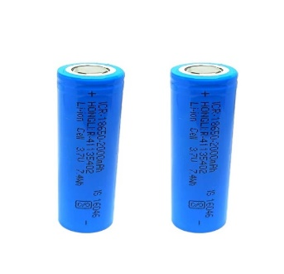

**Fig.3.8 Battery Cell**

A 18560 battery or cells is a cylindrical lithium ion battery. It is rechargeable battery commonly used in portable electronic devices and power tools. They are favored for their high energy density, low self-discharge and long life cycle

**CHAPTER 4**

**Implementation**

**4.1Testing And Verification:**

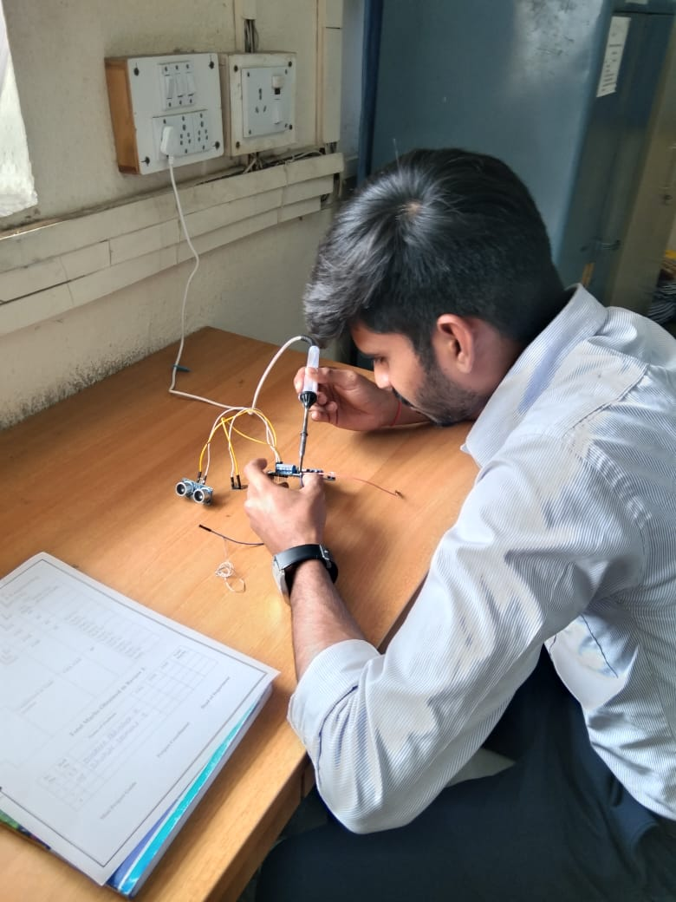

**Fig.4.1.1** **Testing**

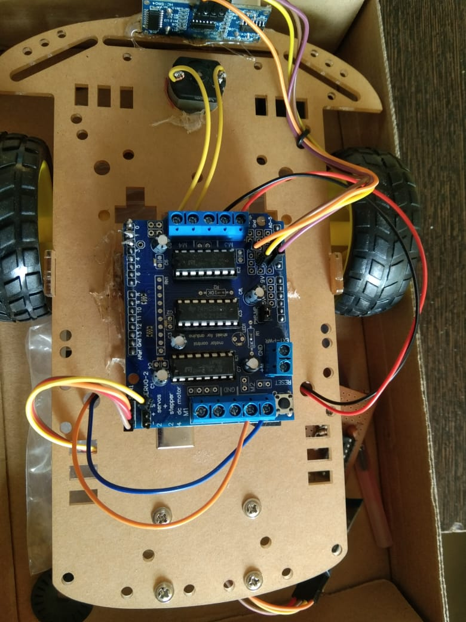

**Fig4.1.2 Verification**

**Testing and Calibration**: Before deployment, the circuit needs to be tested thoroughly to ensure that it recognizes voice commands accurately and controls the grass cutter's operation reliably. Calibration may be required to adjust sensitivity and improve recognition performance voice-controlled grass cutter circuit provides a convenient and hands-free way to operate a grass cutter, offering users greater flexibility and ease of use, especially in scenarios where manual control may be impractical or inconvenient Solar grass cutter has very less moving parts. Due to this it requires less maintenance and no major drawbacks. Our Grass cutting machine does not cause any environmental

**CHAPTER 5**

**Results and Evaluation**

**5.1Hardware Demonstration:**

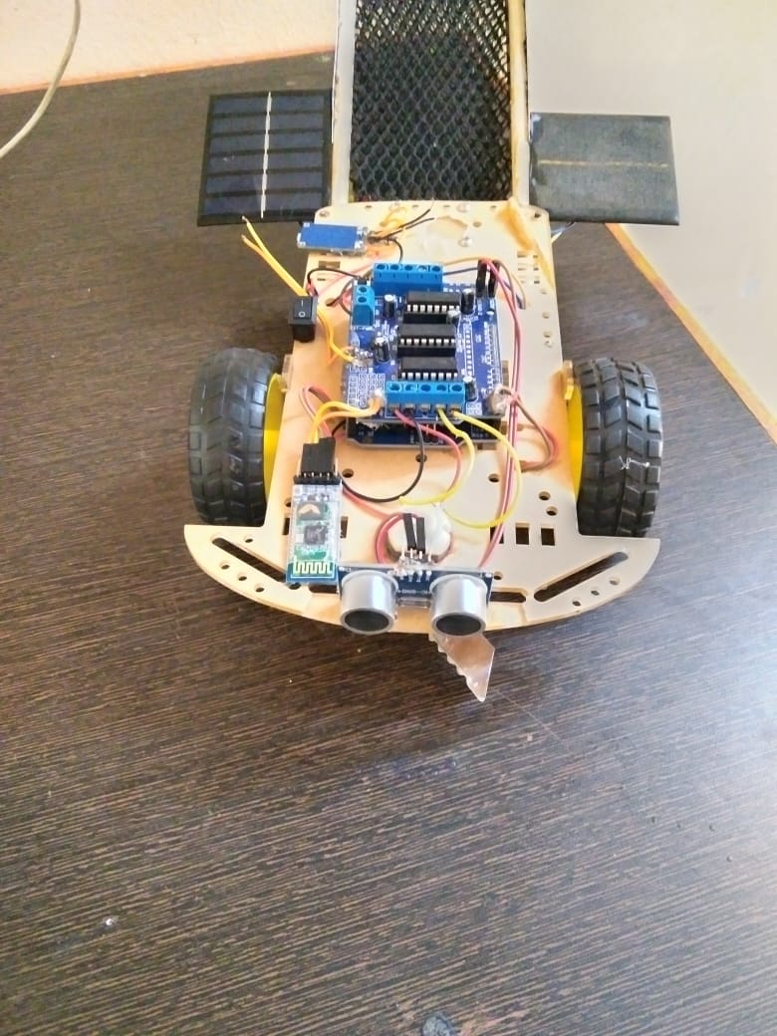

**Fig5.1 Overall Output**

Now a days energy plays an very important role in lot of peoples life. Here the solar panel is used for charging the battery when it gets discharged. Here we can control the grass cutter with the help of Android application so that we can cut the grass in any shape we want and even we can cut the grass without much human effort. For the simulation we have used the proteus version 8.0 & KEIL VERSION 4or5 software in it

**5.2 Performance Evaluation:**

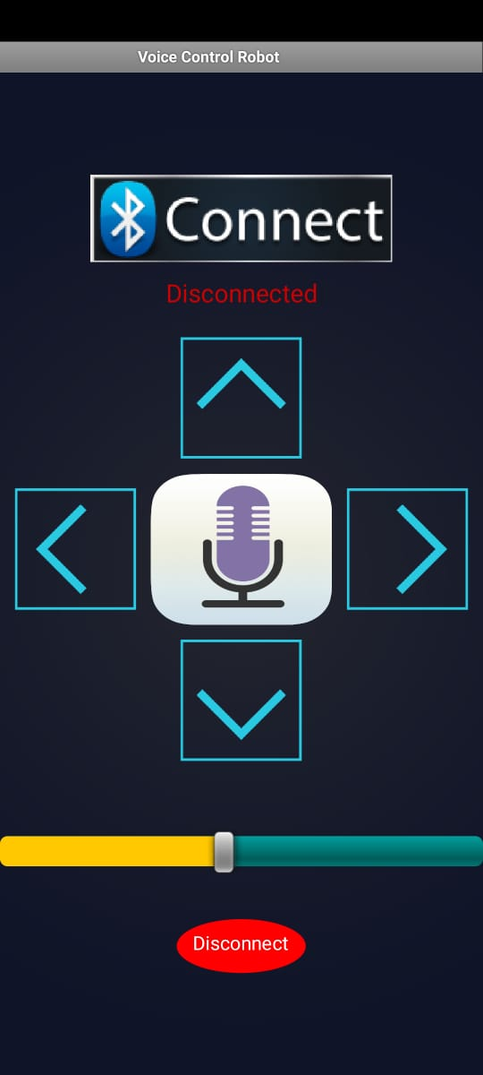

**Fig5.2 Bluetooth App**

**Connecting the Required Connections**

**1 Arduino:**

The Arduino Uno is a microcontroller board based on the ATmega328P. It has 14 digital input/output pins (of which 6 can be used as PWM outputs), 6 analog inputs, a 16 MHz quartz crystal, a USB connection, a power jack, an ICSP header and a reset button. Simply connect it to a computer with a USB cable or power it with a AC to-DC adapter or battery to get started. R. K. Kodaly et al [17] .

**2 Bluetooth:**

For the communication between mobile phone and microcontroller Bluetooth module (HC-05) is used. HC-05 is low power 1.8V operation and is easy to use with Bluetooth SPP (serial port protocol). Serial port Bluetooth module have a Bluetooth 2.0+EDR (enhanced data rate), 3Mbps modulation with complete 2.4GHZ radio transceiver and baseband. Using Bluetooth profile and android platform architecture different type of Bluetooth applications can be developed. Jinan N. Shehab et al [16].

**3 Android:**

Android is an open-source operating system which means that any manufacturer can use it in their phones free of charge. • It was built to be truly open. Android is built on the open 17 Linux Kernel. Furthermore, it utilizes a custom JAVA virtual machine that was designed to optimize memory and hardware resources in a mobile environment. B. Ghazal and K. AI-Khatib [18].

**4 Android Application Operated Bluetooth:**

The Android platform includes support for the Bluetooth network stack, which allows a device to wirelessly exchange data with other Bluetooth devices. • The application framework provides access to the Bluetooth functionality through the Android Bluetooth APIs. Avadhoot R.et al [15].

**CHAPTER 6**

**Conclusion and Future Work**

**6.1 Conclusion:**

334 Mahadevaswamy et al.

Fig. 2 Grass cutting robot

Fig. 3 Rotating blades

Fig. 4 Grass has been cut

5 Conclusion

An automated grass cutter is developed using IOT technology and solar energy. The

robot is able to cut the grass reliably and make the forward movement, backward

Voice Controlled IoT Based Grass Cutter Powered by Solar Energy

334 Mahadevaswamy et al.

Fig. 2 Grass cutting robot

Fig. 3 Rotating blades

Fig. 4 Grass has been cut

5 Conclusion

An automated grass cutter is developed using IOT technology and solar energy. The

robot is able to cut the grass reliably and make the forward movement, backward

Voice Controlled IoT Based Grass Cutter Powered by Solar Energy

334 Mahadevaswamy et al.

Fig. 2 Grass cutting robot

Fig. 3 Rotating blades

Fig. 4 Grass has been cut

5 Conclusion

An automated grass cutter is developed using IOT technology and solar energy. The

robot is able to cut the grass reliably and make the forward movement, backward

Voice Controlled IoT Based Grass Cutter Powered by Solar Energy

334 Mahadevaswamy et al.

Fig. 2 Grass cutting robot

Fig. 3 Rotating blades

Fig. 4 Grass has been cut

5 Conclusion

An automated grass cutter is developed using IOT technology and solar energy. The

robot is able to cut the grass reliably and make the forward movement, backward

Its multitasking working features, the voice controlled in this project has been designed to assist farmers in easing their work and increasing productivity by carrying out various agricultural activities such as spraying pesticides, grass cutting, the agriculture field, and We can utilise this robot to reduce human effort and labour challenges in agriculture due to a lack of human resources the future to conduct numerous agricultural tasks.

**6.2 Future Work:**

Robots are poised to replace human labor in various aspects, leading to increased efficiency in the agricultural sector compared to the present time. These advancements will seamlessly integrate with the utilization of big data in smart farming. Additionally, the combination of satellite imaging, unmanned aerial vehicles (UAVs), and ground robots will enable more comprehensive and diverse data collection, enhancing the overall effectiveness of agricultural operations

**CHAPTER 7**

**References**

[1] .K. Gowthami, K. Greeshma, N. Supraja, “Smart farming using agribot” , International Journal of Applied Engineering Research ISSN 0973- 4562 Volume 14, Number 6, 2019.

[2] G.Sowmya, J.Srikanth, “Automatic weed detection and smart herbicide spray robot for corn fields “,International Journal of Science, Engineering and Technology Research (IJSETR) Volume 6, Issue 1, January 2017.

[3] Patrick M. Piper and Jacob Vogel “Designing of an Autonomous Soil:Monitoring Robot”,2015,IEEE.

[4] Muhammad Ayaz, Mohammad Ammad-uddin, Zubair Sharif, Ali Mansour, and el-Hadi M. Aggoune “ IoT Based Smart Agriculturetowards making the fields talk”, 2019 IEEE.

[5] Nikhil Paliwal,Pankhuri Vanjani ,Jing-Wei Liu ,Sandeep Saini and Abhishek Sharma “Image processing-based intelligent robotic system for assistance of agricultural crops”,Article in International Journal of Social and Humanistic Computing · January 2019.

[6] C. Jeeva, Saher Mairaj, Archit keshav Gangal and Farheen “Agricultural Automation System with Field Assisting Robot- AgroBot”, International Journal of Pure and Applied Mathematics Volume 118 No. 20 2018.

[7] V. Radhika, B. Sharmila, R. Ramya, M. Gopisri “. Design and Implementation of Agrobot with Automatic Sun Tracking”, International Journal of Engineering and Advanced Technology (IJEAT) ISSN: 2249 – 8958, Volume-9 Issue-2, December, 2019.

[8] Shubham Khandelwal,Neha Kaushik, Sagar Sharma, “AGROBOT: Sowing and Irrigating Farming Machine”,Volume 8, No. 5, May-June 2017International Journal of Advanced Research.

[9] Ponnu Priya Saju, Anila P.V, “AGROBOT: Sowing and Irrigating Farming Machine”, International Journal for Research in Engineering Application & Management (IJREAM) ISSN : 2454-9150 Vol-05, Issue03, June 2019.

[10] Mr. V. Gowrishankar Dr. K. Venkatachalam, “IoT Based Precision Agriculture using Agribot”, Global Research and Development Journal for Engineering | Volume 3 | Issue 5 | April 2018

**Appendix**

**8.1 Programming:**

**#include "AFMotor.h“**

**const int MOTOR_1 = 1;**

**const int MOTOR_2 = 2;**

**const int MOTOR_3 = 3;**

**const int MOTOR_4 = 4;**

**AF_DCMotor motor1(MOTOR_1, MOTOR12_64KHZ);**

**// create motor object, 64KHz**

**AF_DCMotor motor2(MOTOR_2, MOTOR12_64KHZ);**

**AF_DCMotor motor3(MOTOR_3, MOTOR12_64KHZ);**

**// create motor object, 64KHz**

**AF_DCMotor motor4(MOTOR_4, MOTOR12_64KHZ);**

**int state;**

**int Speed = 130;**

**void setup()**

**{**

**motor1.setSpeed(Speed);**

**motor2.setSpeed(Speed);**

**motor3.setSpeed(Speed);**

**motor4.setSpeed(Speed);**

**Serial.begin(9600);**

**delay(500);**

**}**

**void loop()**

**{**

**if(Serial.available() > 0)**

**{**

**//if some date is sent, reads it and saves in state**

**state = Serial.read();**

**if(state > 10){Speed = state;} }**

**motor1.setSpeed(Speed); // set the motor speed to**

**motor2.setSpeed(Speed);**

**motor3.setSpeed(Speed);**

**motor4.setSpeed(Speed); //===============================================================================// Key Control Command//=============================================================================== if(state == 1){forword(); }**

**// if the state is '1' the DC motor will go forward**

**else if(state == 2){backword();**

**}**

**else if(state == 3){turnLeft();**

**}**

**else if(state == 4){turnRight();**

**}**

**else if(state == 5){Stop();**

**}**

**// if the state is '5' the motor will Stop/////////////////////////////////////END\\\\\\\\\\\\\\\\\\\\\\\\\\\\\\\\\\\\\\\\\//===============================================================================// Voice Control Command//===============================================================================else if(state == 6)**

**{turnLeft(); delay(400);**

**state = 5;}**

**else if(state == 7)**

**{turnRight(); delay(400); state = 5;}**

**/////////////////////////////////////END\\\\\\\\\\\\\\\\\\\\\\\\\\\\\\\\\\\\\\**

**delay(80);**

**}**

**void forword()**

**{**

**motor1.run(FORWARD); // turn it on going forward**

**motor2.run(FORWARD);**

**motor3.run(FORWARD);**

**motor4.run(FORWARD);**

**}**

**void backword()**

**{**

**motor1.run(BACKWARD); // the other**

**motor2.run(BACKWARD);**

**motor3.run(BACKWARD);**

**motor4.run(BACKWARD);**

**}**

**void turnRight()**

**{**

**motor1.run(FORWARD); // the other right**

**motor2.run(FORWARD);**

**motor3.run(BACKWARD);**

**motor4.run(BACKWARD);**

**}**

**void turnLeft()**

**{**

**motor1.run(BACKWARD); // turn it on going**

**motor2.run(BACKWARD);**

**motor3.run(FORWARD);**

**motor4.run(FORWARD);**

**}**

**void Stop()**

**{**

**motor1.run(RELEASE); // stopped**

**motor2.run(RELEASE);**

**motor3.run(RELEASE);**

**motor4.run(RELEASE);**

**}**

**}**